Metadata for FAST-3 ADCP data from the FORCE site
Joel Culina, Aug 2020

- Purpose

This note provides metadata for ADCP data collected at the FORCE site in 2017-18.

- Background

In 2017-19, a project led by Acadia University and FORCE sought to quantify capabilities of stationary and mobile sensors in deriving the spatiotemporal distribution of fish species. In 2017-18, a bottom-mounted platform (the ‘FAST-3’ platform) was deployed three (3) times, for approximately two (2) months duration each time (see Table 1). Its sensor suite included fish sensors and a Signature 500 acoustic Doppler current profiler (see Fig. 1). The project’s findings are summarized in Viehman et al. 2019.

Table 1: FAST-3 time and location
Start date | End date | Location
14-Dec-2017 | 22-Feb-2018 | 45˚21’46.8” N  64˚25’39.7” W
30-Mar-2018 | 23-May-2018 | 45˚21’47.3” N  64˚25’38.9” W
15-Sep-2018 | 28-Nov-2018 | 45˚21’47.5” N  64˚25’39.9” W

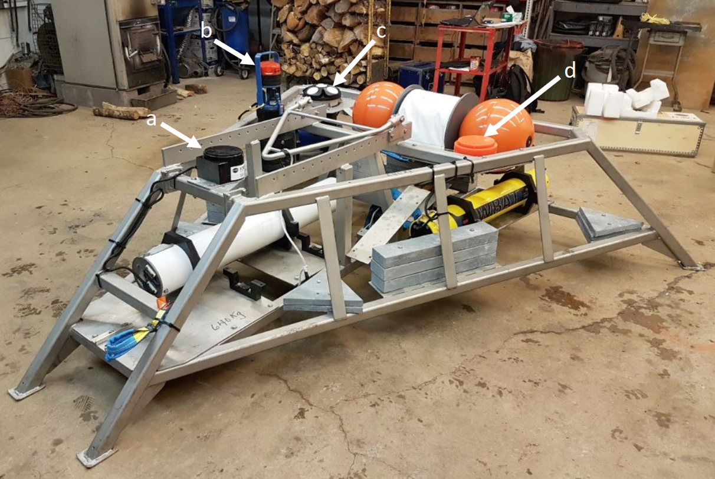
Figure 1: FAST-3 platform prior to deployment at the FORCE test site. (a) ASL AZFP transducer; (b) Aanderaa SeaGuard RCM; (c) Nortek Signature 500; (d) Simrad EK80 WBAT transducer.
- ADCP configuration parameters

The configuration parameters are summarized in Table 2. The Raw folder (see below) contains a comprehensive set of sampling/configuration parameters.

For two of the deployments – Dec_2017 and Sep_2018 – the acoustic altimeter was (inadvertently) disabled during configuration, resulting in poor resolution of the (non-directional) wave statistics. Hence the wave data from these deployments were not included in the data package. The wave statistics were included for the Mar_2018 deployment, for which the altimeter was enabled.

Table 2: FAST-3 ADCP settings
Parameter | Value | Notes
ADCP | Signature 500 | Manufacturer: Nortek
ADCP sampling frequency | 4 Hz for 5 mins every 15 mins  (Dec 2017 & Sep 2018)  2 Hz (slant beams) & 1 Hz (altimeter) for 5 mins every 15 mins (Mar 2018)
ADCP altitude above seabed | 0.5 metres
ADCP blanking distance | 1 metre | Use ‘BurstVelocityENU_Range’ in the processed files to obtain bin depth
ADCP vertical bin size | 1 metre

- ADCP post-processing parameters

The raw ‘ad2cp’ data, collected in situ by the Signature 500, was post-processed in Nortek’s ‘Ocean Contour’ software (V2.1.0 R2065) to derive current velocities and wave statistics.

There are four folders corresponding to four types of data:
- Raw: The ad2cp files directly obtained from the ADCP
- Converted_Raw: The raw ad2cp files are converted into mat and nc files. No processing is applied in this conversion.
- Averaged_ENU: Averaged/current velocities, in East-North-Up (ENU) coordinates, found by averaging over each 5-minute dataset (hence, averaged velocities are found every 15 minutes). Velocities are derived in ENU coordinates from the four (4) slant beams.
- Wave_Stats: Wave statistics derived for each 5-minute dataset (hence, wave statistics are found every 15 minutes).

Where applicable, the processing parameter ‘magnetic declination’ was set to -17.22°. For Wave_Stats and Averaged_ENU, the default processing parameters were used.

The sections below show screenshots of the post-processing parameters used to derive each processed dataset.

- ADCP post-processing parameters: Averaged_ENU

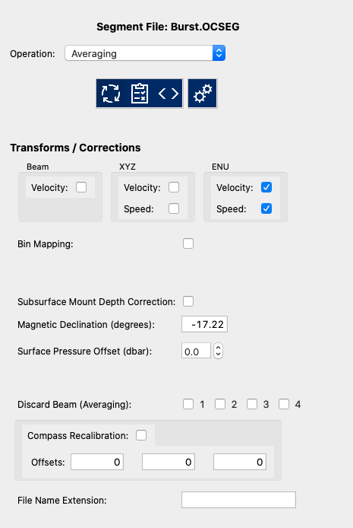
Figure 2: General parameters used in averaging – set coordinate system and magnetic declination.

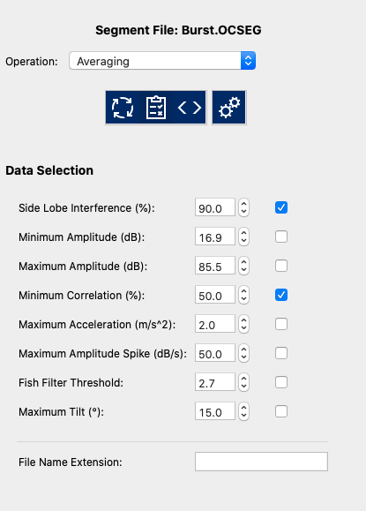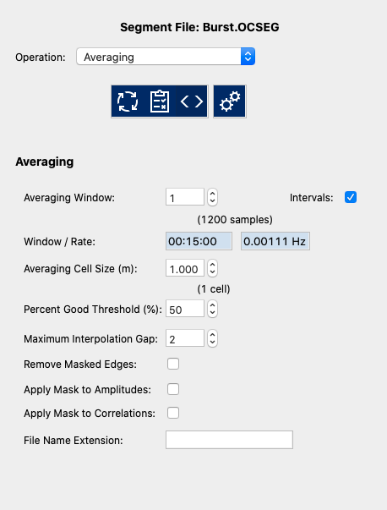
Figure 3: Parameters used for filtering of bad data (left); and for averaging (right).

- ADCP post-processing parameters: Wave_Stats

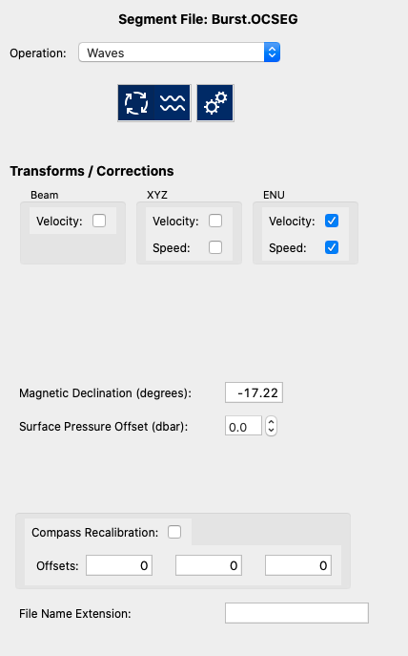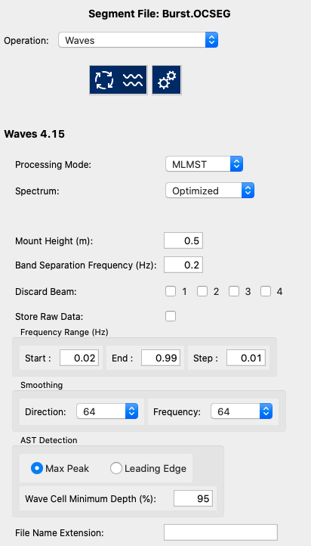
Figure 4: Parameters used in deriving wave statistics.

- References

- Viehman, H., Hasselman, D., Boucher, T., Douglas, J., Bennet, L. Integrating Hydroacoustic Approaches to Predict Fish Interactions with In-stream Tidal Turbines. 49 pp. 2019.

,

